**Module 3 Critical Thinking Assignment**

**Introduction**

This two-part assignment is intended to demonstrate a facility with Python variables and data types.

**Part 1:**

Write a program that calculates the total amount of a meal purchased at a restaurant. The program should ask the user to enter the charge for the food and then calculate the amounts with an 18 percent tip and 7 percent sales tax. Display each of these amounts and the total price.

Pseudo code

1. Prompt the user to enter the charge for the food
2. Calculate tax as charge*0.07
3. Calculate tip as (charge +tax)*0.18. Note: Another way to do this would be to calculate it as charge*0.18. The instructions don’t specify which way to do it. I personally do it this way.
4. Calculate total as charge + tax + tip
5. print(‘Cost of meal:’,charge)
6. print(‘Tax: {:.2f}’.format(tax))
7. print(‘Tip: {:.2f}’ .format tip))
8. print(‘Total: {:.2f} ‘.format total))

Screenshot of code

charge = float(input('Input cost of the meal before tax and tip\n'))

tax = charge * 0.07

tip = (charge+tax) * 0.18

total = charge + tax + tip

print('Cost of meal: ${*:.2f*}'.format(charge))

print('Tax:          ${*:.2f*}'.format(tax))

print('Tip:          ${*:.2f*}'.format(tip))

print('Total:        ${*:.2f*}'.format(total))

Screenshot of output

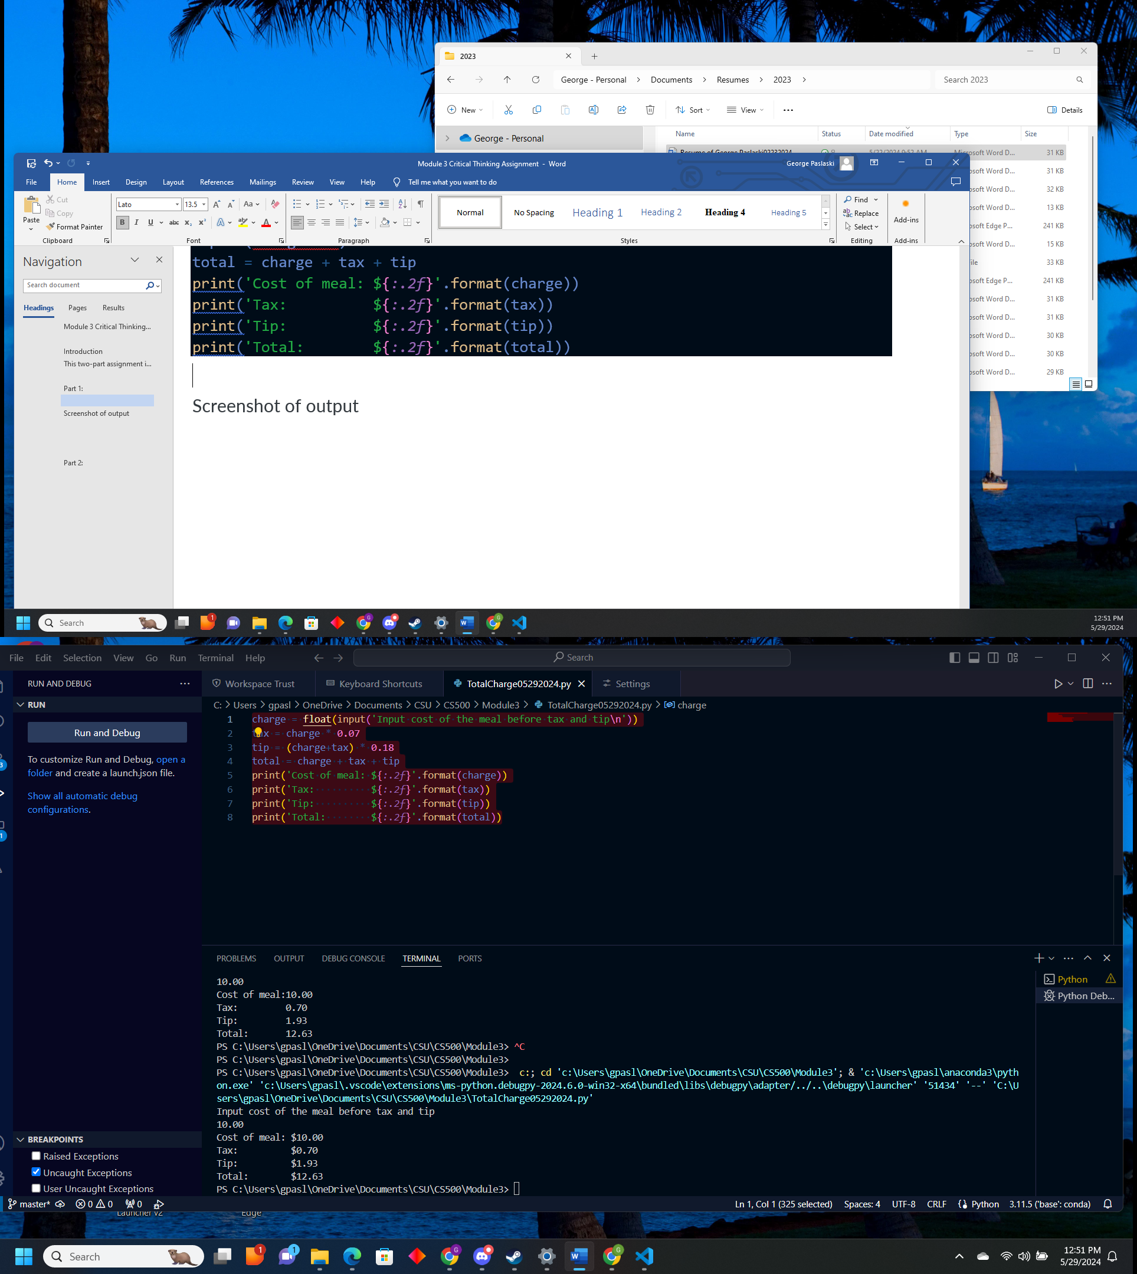

**Part 2:**

Many people keep time using a 24-hour clock (11 is 11am and 23 is 11pm, 0 is midnight). If it is currently 13 and you set your alarm to go off in 50 hours, it will be 15 (3pm). Write a Python program to solve the general version of the above problem. Ask the user for the time now (in hours) and then ask for the number of hours to wait for the alarm. Your program should output what the time will be on a 24-hour clock when the alarm goes

Psuedo code

1. prompt user to enter current time in hours (integer from 0-23). Store it as currentTime
2. prompt user to enter number of hours before alarm goes off. Store it as waitHours
3. Add currentTime and WaitHours to get endTime
4. Divide endTime by 24 and keep the remainer endTime%24 call this alarmTime
5. Print(‘The time on the 24 hour clock when the alarm will ring is {}’.format(alarmTime))